**Cucumber Automation Testing Tool Installation and Configuration**

**Installation Steps for Cucumber**

**Step 1:** Install Java on your computer. Once you install JDK, you no need to install JRE separately.

Download and install the Java Software Development Kit (JDK). You download the JDK file from this location:

<http://www.oracle.com/technetwork/java/javase/downloads/index.html>.

After that set jdk path in Environment Variable

System variable- JAVA_HOME=> C:\Program Files\Java\jdk1.8.0_91

Path=>%JAVA_HOME%\bin

Class path=> C:\Program Files\Java\jdk1.8.0_91\lib

**Step 2:** Install Eclipses IDE

Now download “Eclipse IDE for Java Developers”. You can download eclipses from this location: <http://www.eclipse.org/downloads/>

Or you can download installer and select Eclipse IDE for Java Developers during installation

1. Click on Download 64 BIT button

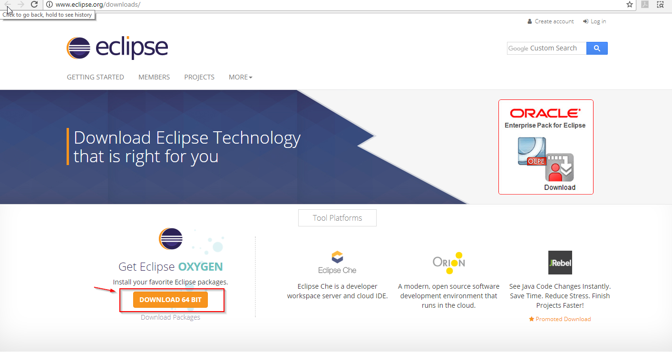

1. Once download finished, run file “eclipse-inst-win64.exe” file using administrator
2. Select **“Eclipse IDE for Java EE Developers”**

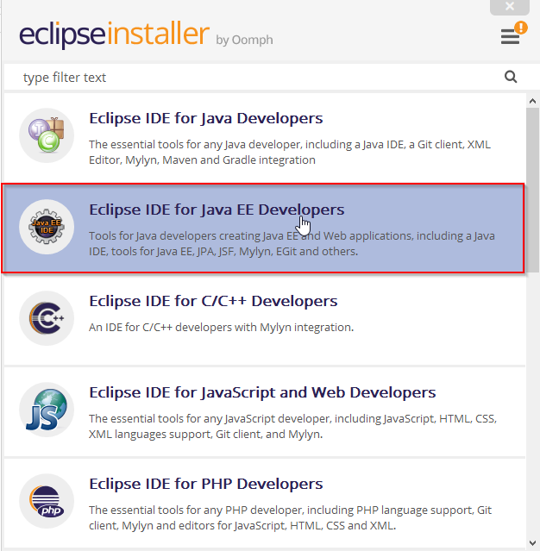

1. Select location where you want to install and hit INSTALL button

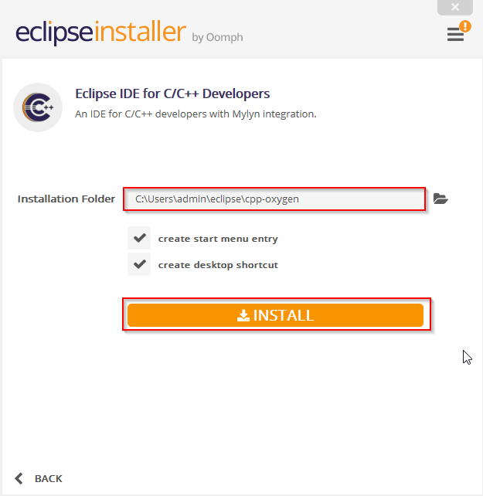

1. Accept the eclipse installer agreement by clicking button “Accept Now”

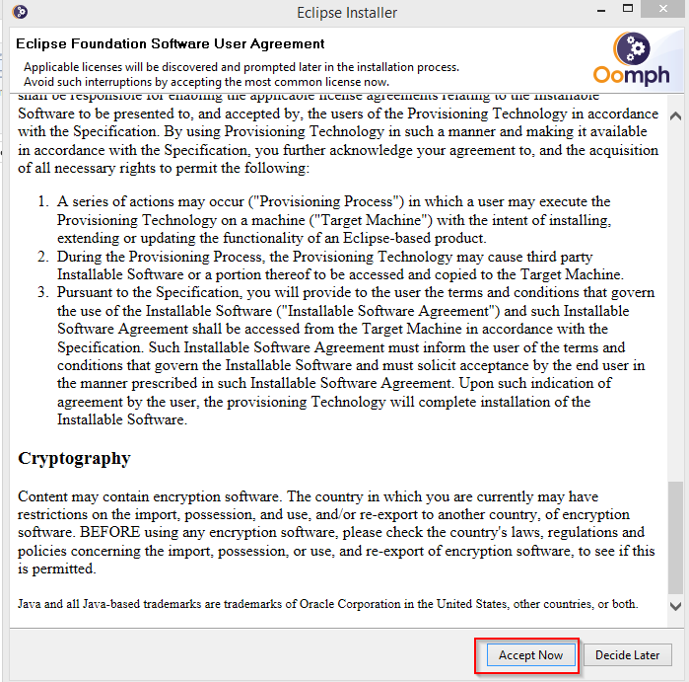

1. Once Installation Completed, click on Launch button shown in image 1 and keep default workspace and hit Launch button shown in second image, so it will launch the eclipse .

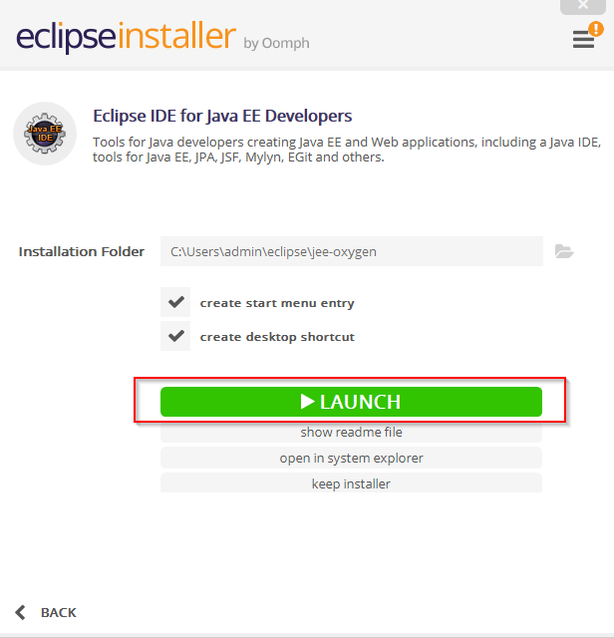



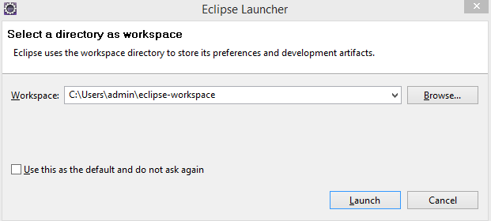

**Step 3: Install TestNG**

1. Click on the ***Help*** from the top menu in ***Eclipse*** and select ‘***Install New Software..***‘

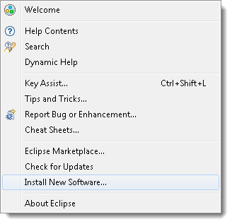

1. Click on the ***Add***button on the newly opened window.

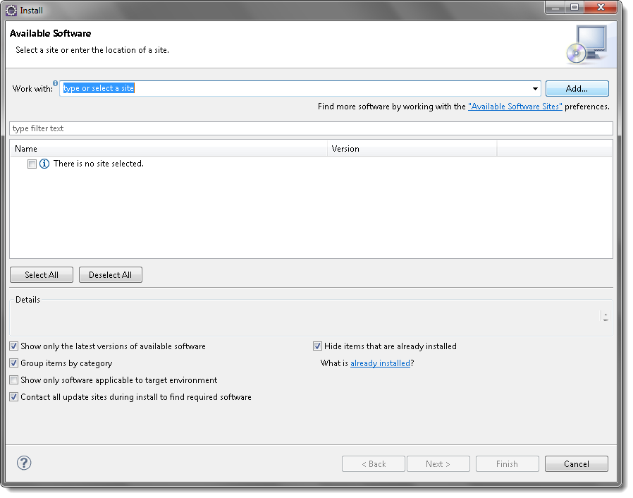

**3)** Type name as you wish, let’s take “TestNG” and type “http://beust.com/eclipse/” as location. Click OK.

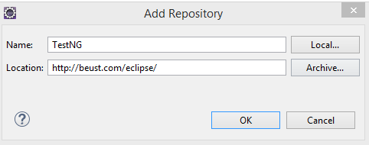

4) Enable TestNG checkmark and click on Next->Next button.

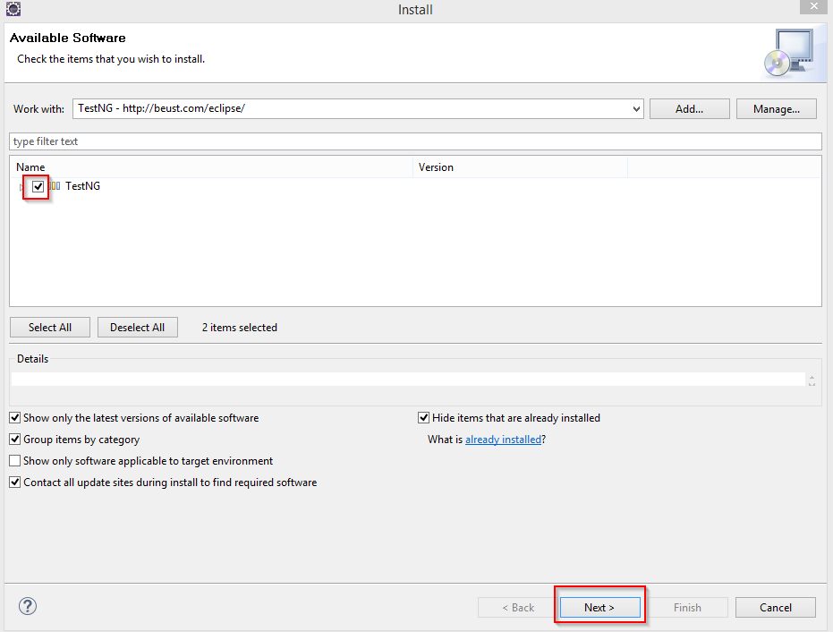

5) Accept the license agreement and click Finish button

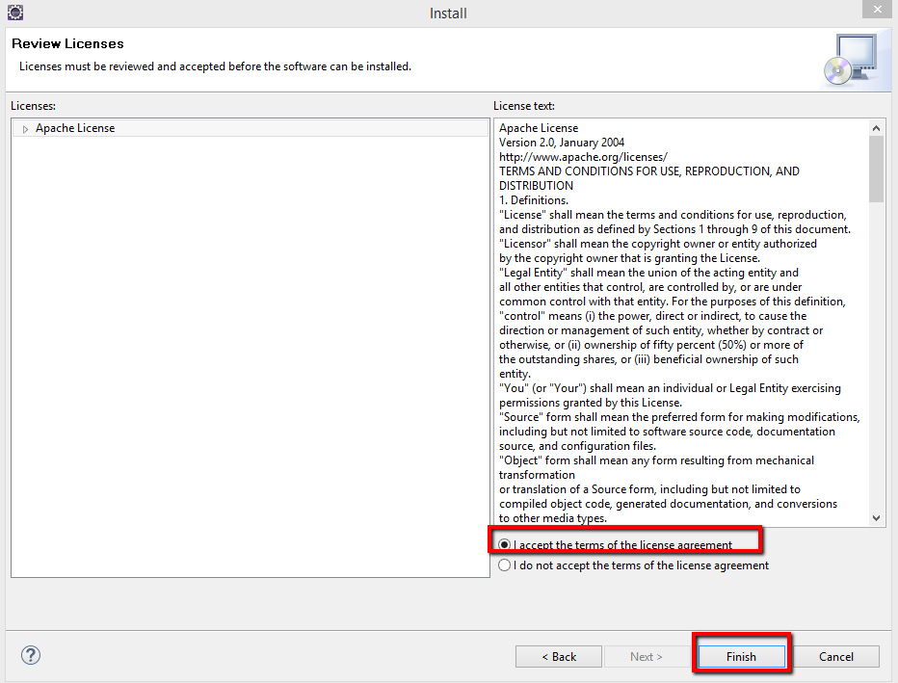

6) Click on “Install anyway” button

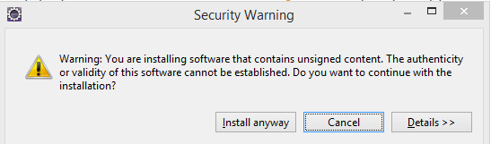

7) Click on Restart Now button for changes to take effect.

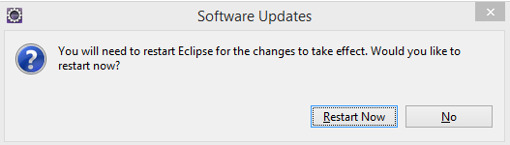

You are all done now with installing TestNG Plugin.

**Step 4: Install Maven**

1. Click on the ***Help*** from the top menu in ***Eclipse*** and select ‘***Install New Software..***‘



1. Click on the ***Add***button on the newly opened window.



1. In the Name box, type ‘**Maven**‘ and in the Location box, type ‘***http://download.eclipse.org/technology/m2e/releases/***‘

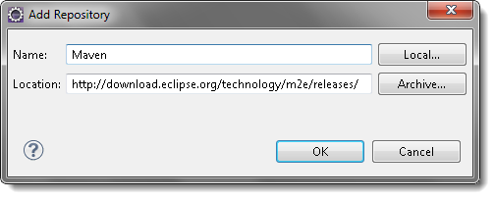

***Note:***The URL is the location where you can download the Maven for Eclipse.

1. A check-box will appear in the pop window, ***Check*** the check-box and click on ***Next*** button.

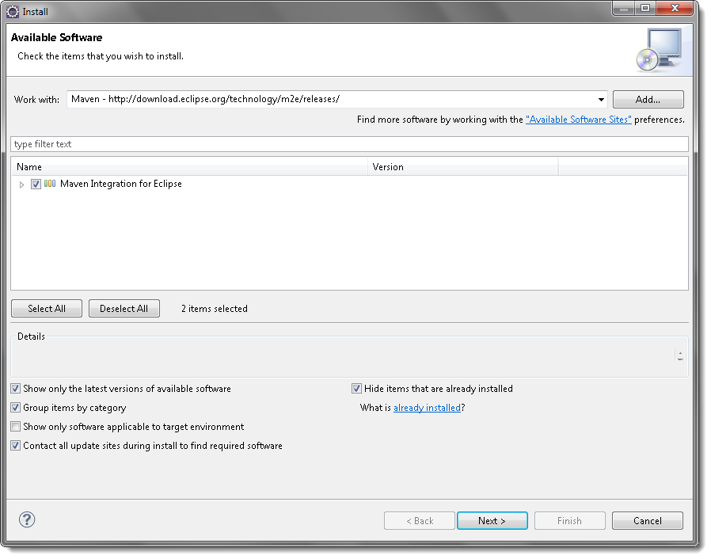

5) Please wait for some time and let the window complete its processing. It will not take long but 2 or 3 minutes.

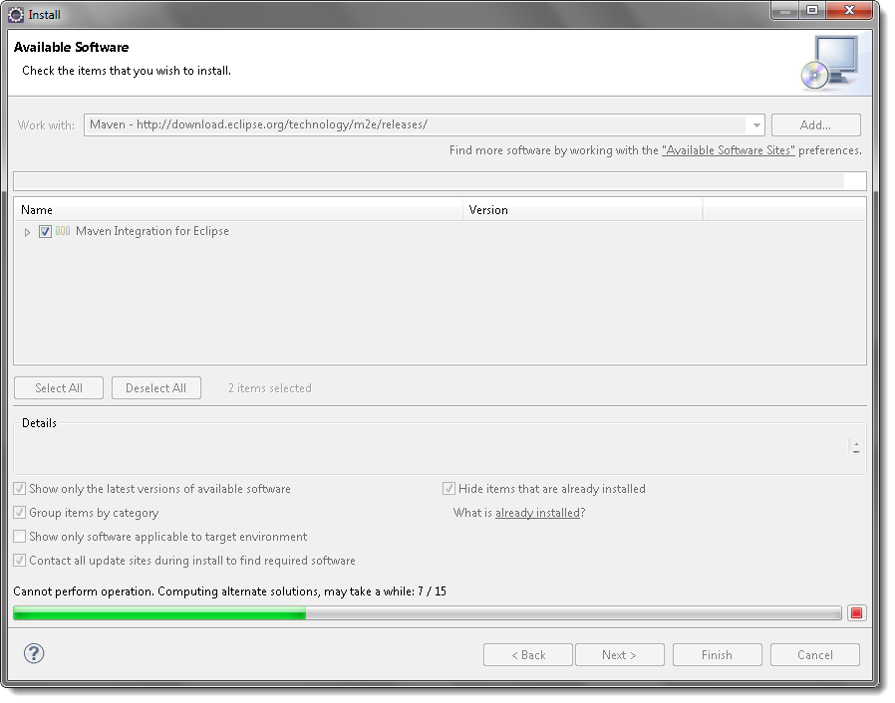

6) Keep the default settings and click on ***Next*** button.

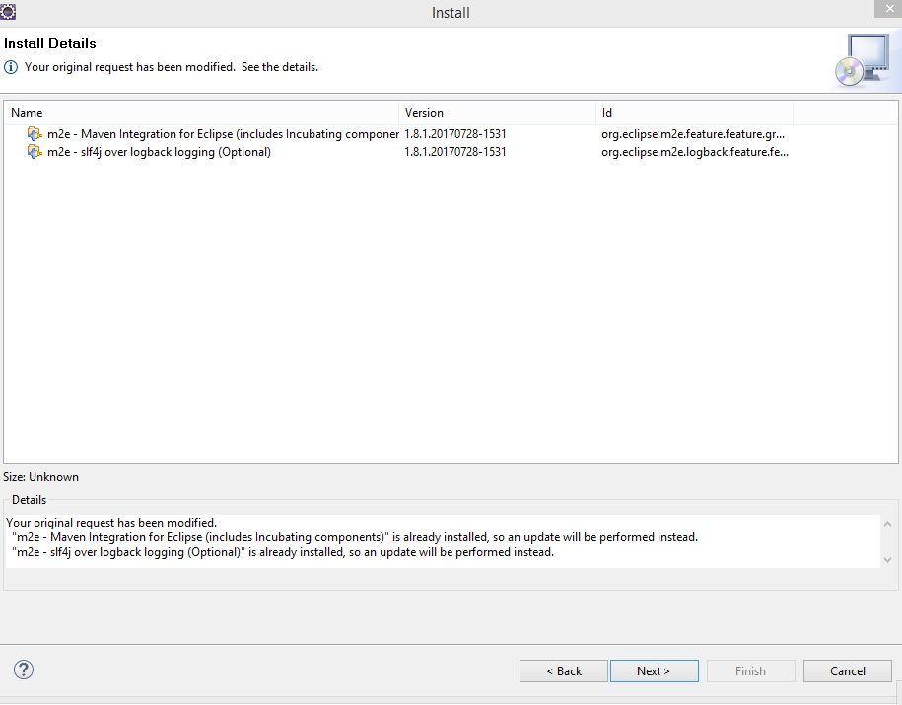

7) Accept the ‘***Terms and Conditions***‘ and move forward by clicking on ***Finish*** button.

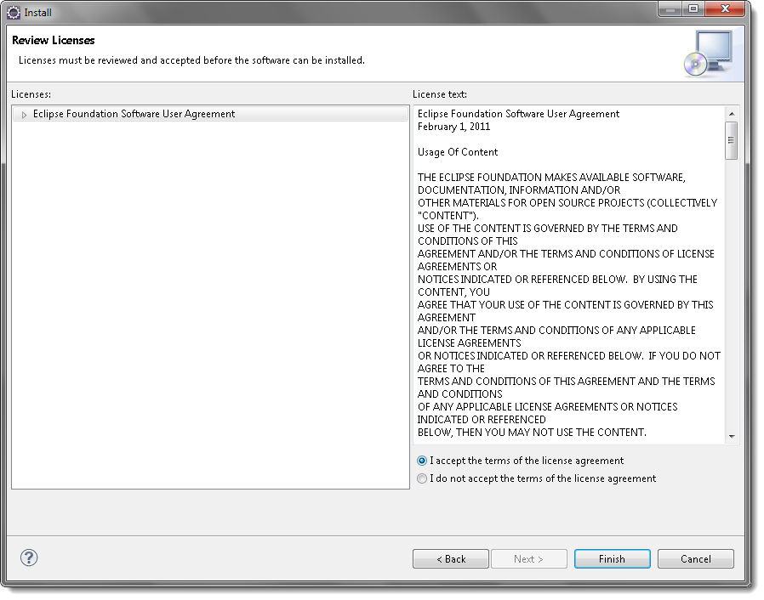

8) Wait while it finish the installation.

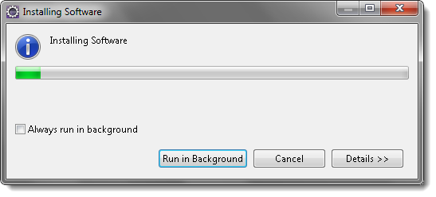

9) Once the installation is finished, it will ask you to restart the Eclipse. Please click on ***Restart Now***, so that changes can be reflected properly.

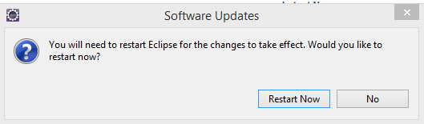

**Step 5: Install Cucumber plugin**

1. Click on the ***Help*** from the top menu in ***Eclipse*** and select ‘***Install New Software..***‘



1. Click on the ***Add***button on the newly opened window.



3) Type name as you wish, let’s take “***Cucumber***” and type “***http://cucumber.github.com/cucumber-eclipse/update-site***” as location. Click ***OK***.

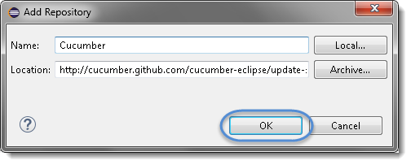

4) You come back to the previous window but this time you must see ***Cucumber Eclipse Plugin*** option in the available software list. Just ***Check*** the box and press “***Next***” button.

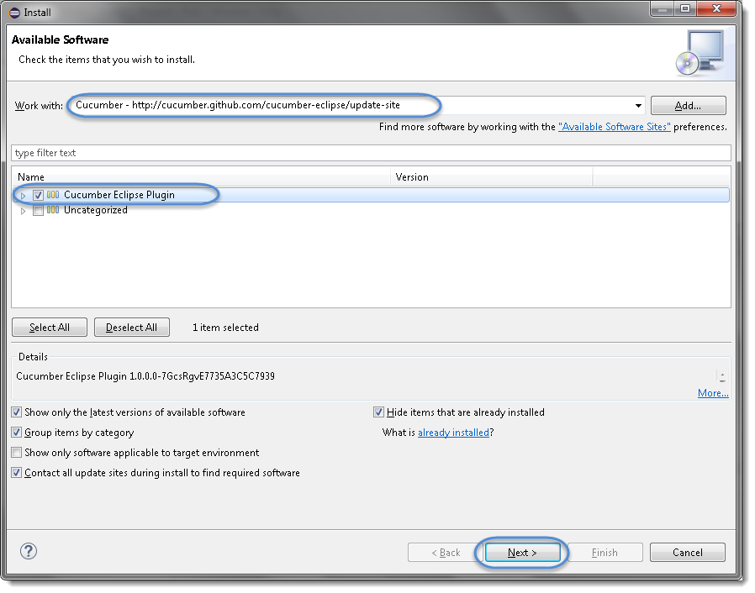

***Note:*** If running behind a proxy server and you get a ‘HTTP Proxy Authentication Required’ error you may need to contact a system administrator to set up your proxy server settings.

5) Click on ***Next***.

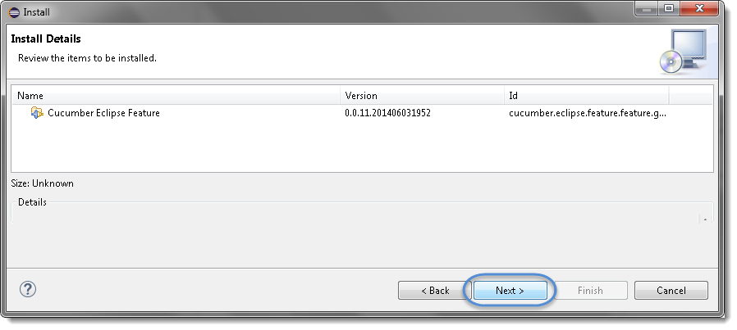

6) Click “***I accept the terms of the license agreement***” then click ***Finish***.

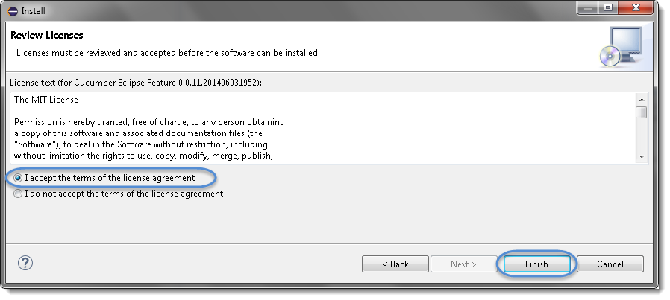

7) Let it install, it will take few seconds to complete.

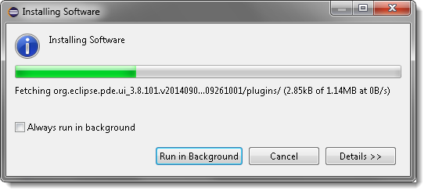

8) You may or may not encounter a Security warning, if in case you do just click ***Install anyway***.

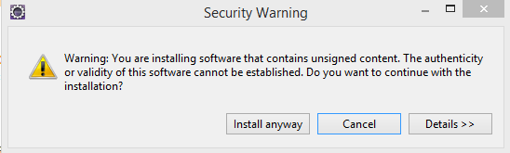

9) Once the installation is finished, it will ask you to restart the Eclipse. Please click on ***Restart Now***, so that changes can be reflected properly.



**Step 6: Import project**

1) Once Eclipse restarted, Click on File-> Import

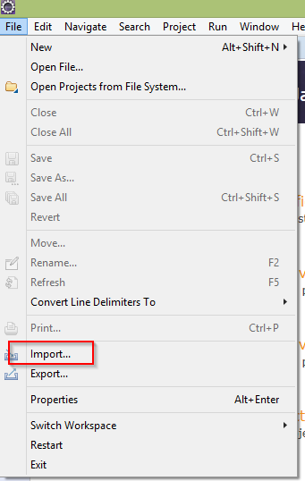

2) Expand **Maven** folder, select **Existing Maven Projects** and click **Next**

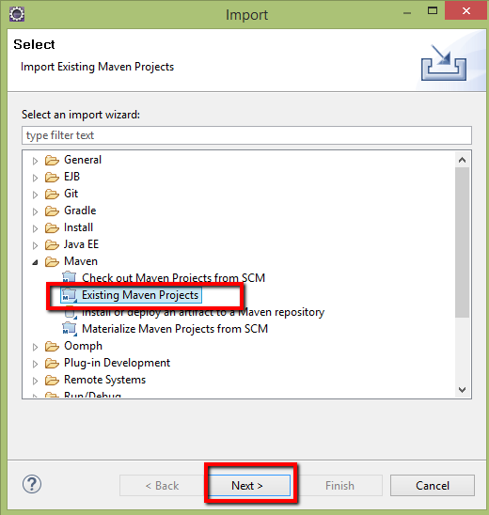

3) Click on Browse button to select the directory under which we have extracted the project.

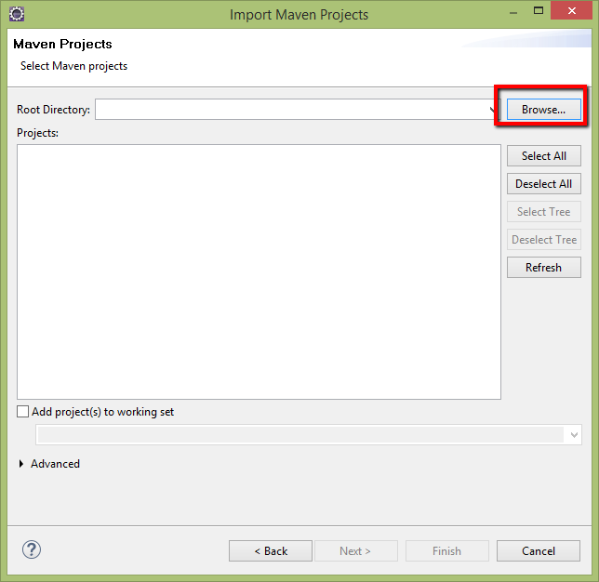

4) Select Directory under which we have extracted the project and Click OK button

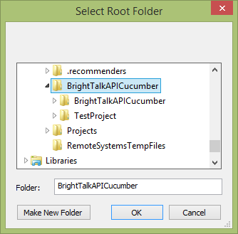

5) Now we are on back page select the project and click **Finish** button.

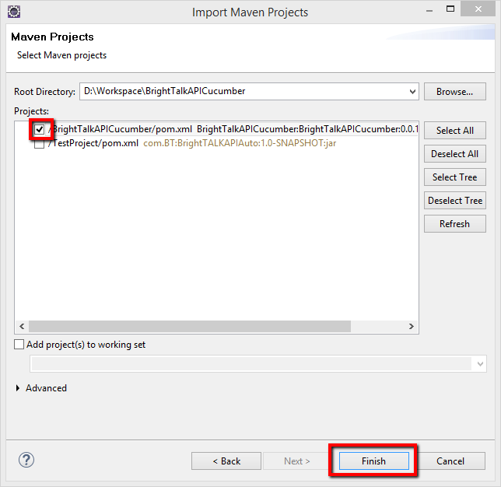

Once click on Finish button, it will take 3-4 minutes to load, build and download the dependency files for project.

6) ***Right click*** on project, move cursor to **Build Path** from list -> select **Configure Build Path,** it will open Properties for project

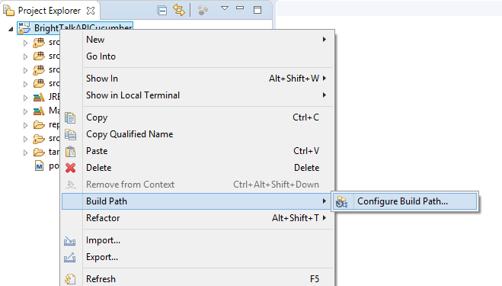

7) Click on Libraries, and verify JDK is selected, if not, then click on Add Library button.

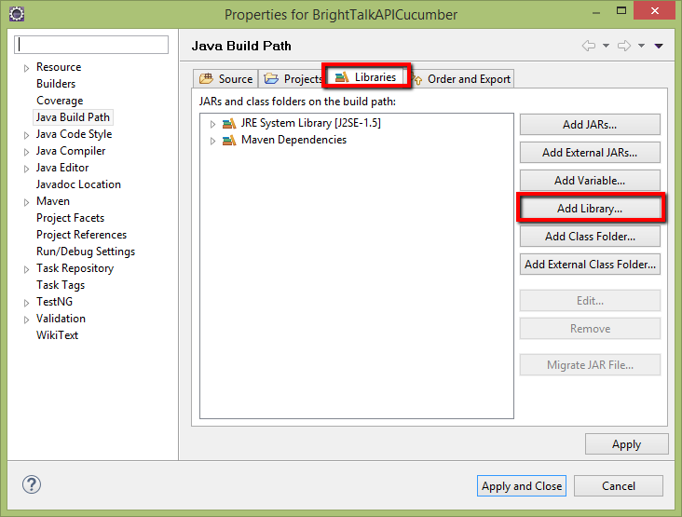

8) Select JRE System Library and Click **Next** button, it will allow you to select JDK

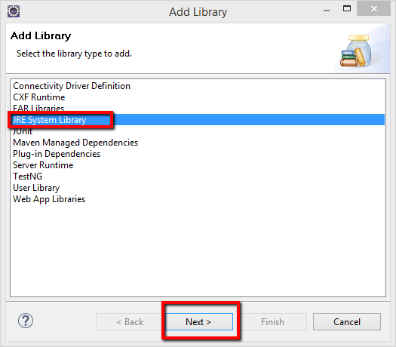

9) Select Alternate JRE and click on Installed JRE’s, it will populate Preferences window.

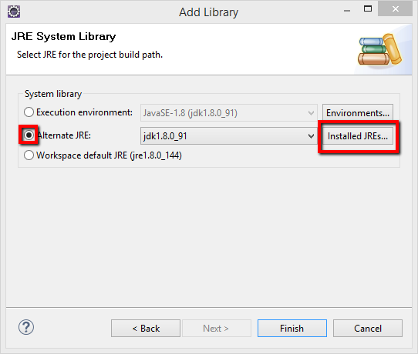

10) Click on **Add** button to set jdk path for the project, then select “Standard VM” and click Next , it will populate another window “Add JRE”

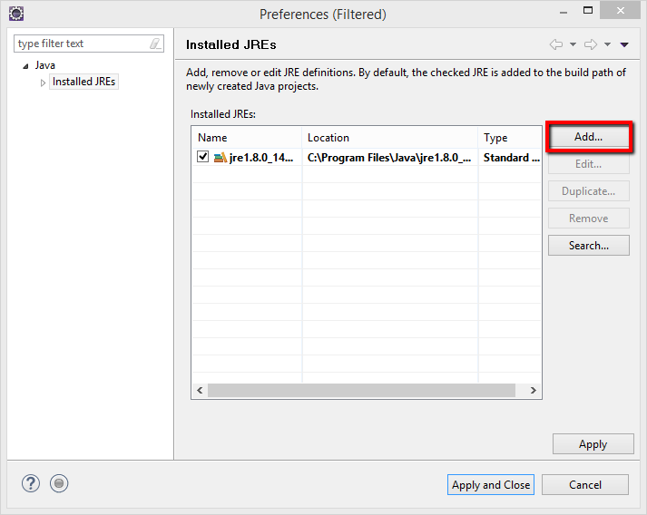

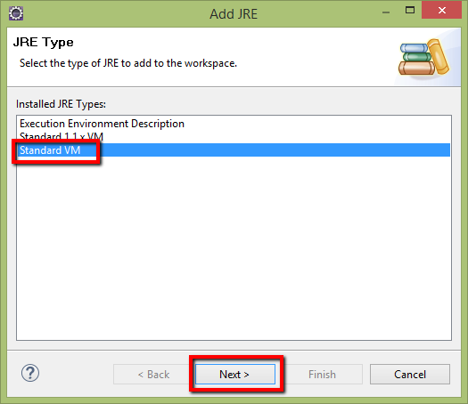

11) Once “Add JRE” window open, add JDK Home path: C:\Program Files\Java\jdk1.8.0_91 and Name, then click **Finish** button, it will shows you previous window with JDK path added.

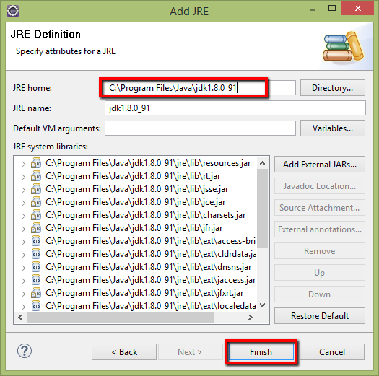

12) Now select added JDK and click on button **Apply And Close,** which will navigate to Add library window.

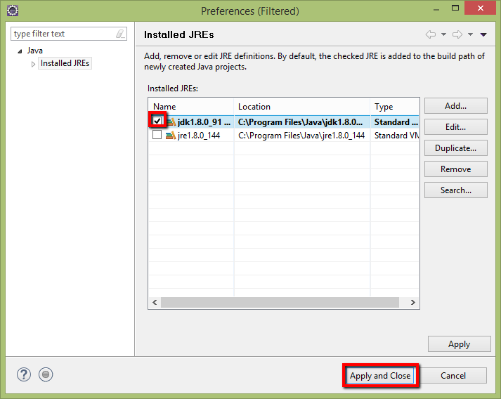

13) Select Default workspace as JDK and click **Finish** button

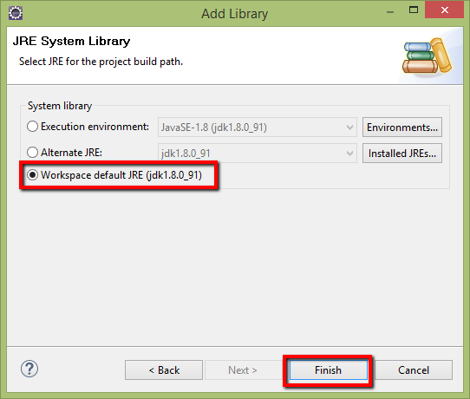

14) Once we set up the JDK path, then add other libraries like **TestNG** shown in below image.

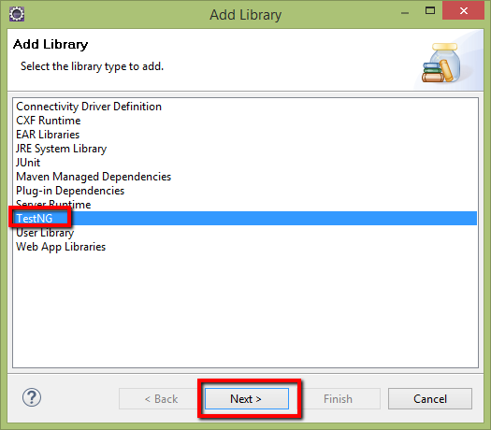

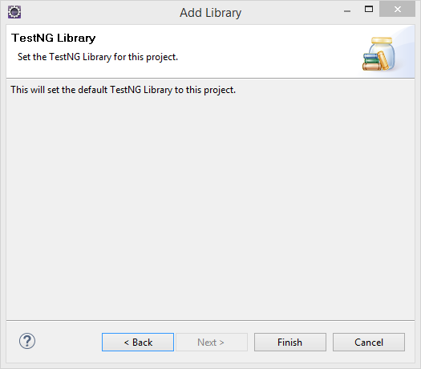

15) After adding the JDK, TestNG libraries, go to Order and Export , enable JDK, TestNG and Maven dependencies and click **Apply and Close**.

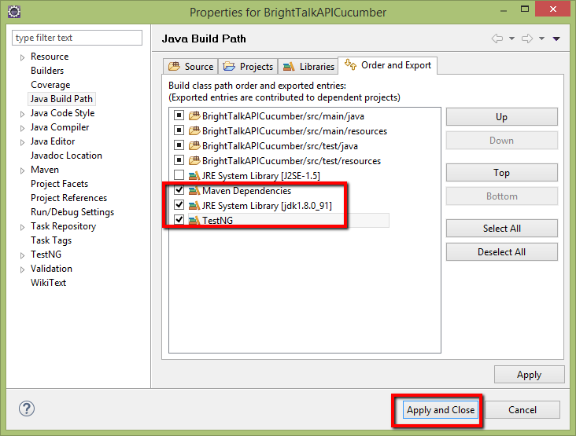

Now Open pom.xml, update JDK version under dependency and save the pom.xml file.

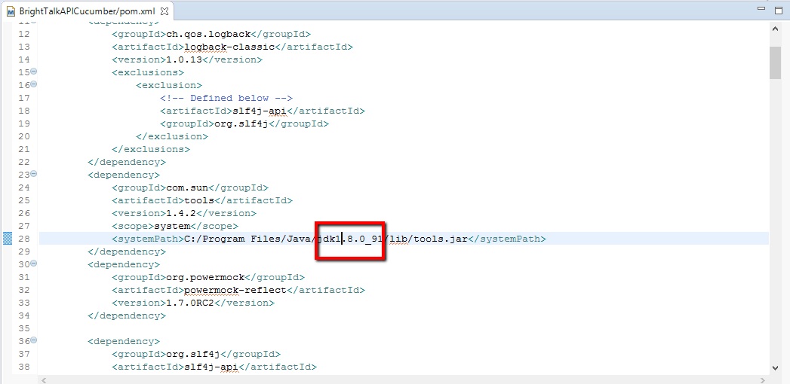

**Project Execution:**

1. Now once all above set-up done then open “**testRealmAPI.feature”** fileand update the unique name in first field of the table for the scenario where added a comment like “#update the name” and save the file.

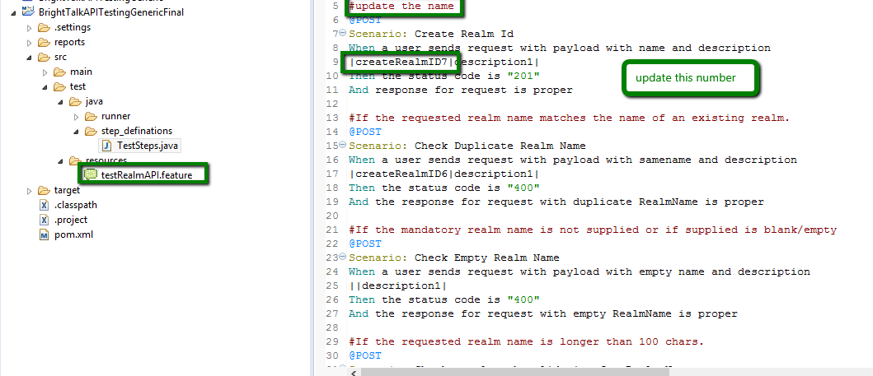

1. After above changes, open **CucumberRunner.java** file which is present under “src->test->java->runner->” location.

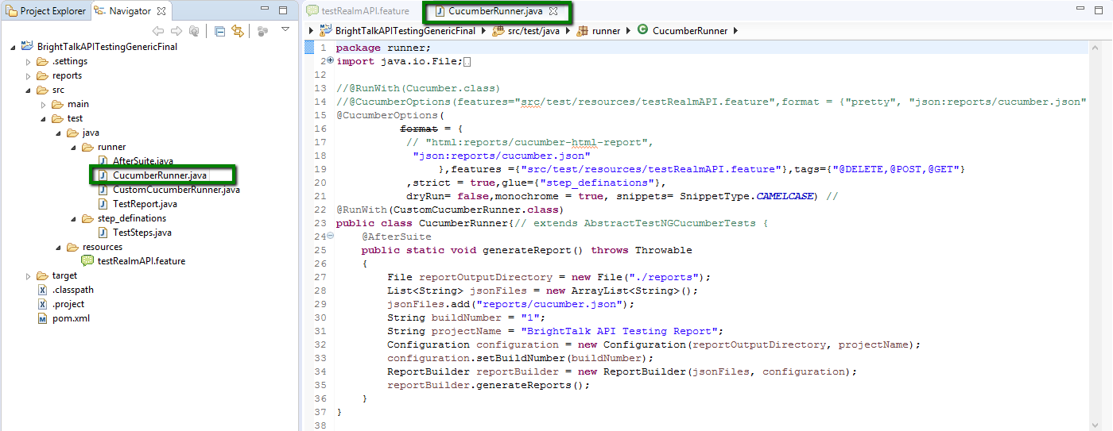

1. Now right click in the file and select ***Run As->Junit Test.***

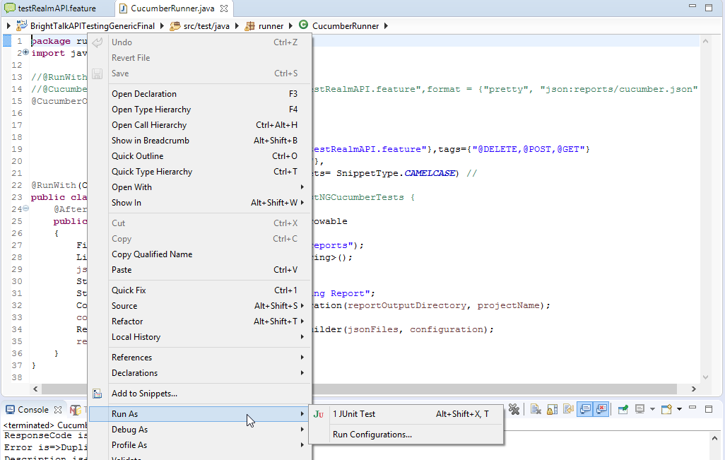

1. Now observe the console for the result. (If console window is not present then go to ***Windows->Show View->Console***)

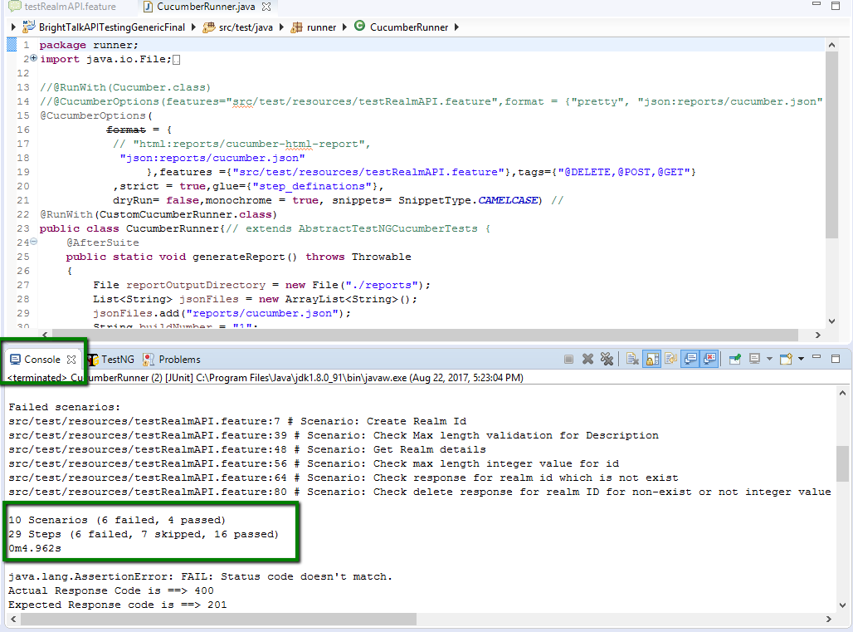

That’s all, now you can see the reports after refreshing the Project folder by right click-> Refresh. Once project refreshed, we can see the reports folder under the project. Now open any report file which we want to see.